1. **Where should you move the Queen to attack the Black King and Bishop?**

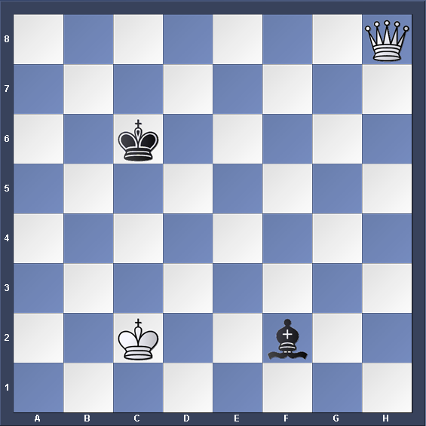

|  |  |  |
| --- | --- | --- |
| **Move No.** | **White** | **Black** |
| **1.** |  |  |
|  |  |  |
|  |  |  |

**White To Play**

1. **White has to use his Queen to attack the Black King and Rook.**

**White To Play**

|  |  |  |
| --- | --- | --- |
| **Move No.** | **White** | **Black** |
| **1.** |  |  |
|  |  |  |
|  |  |  |

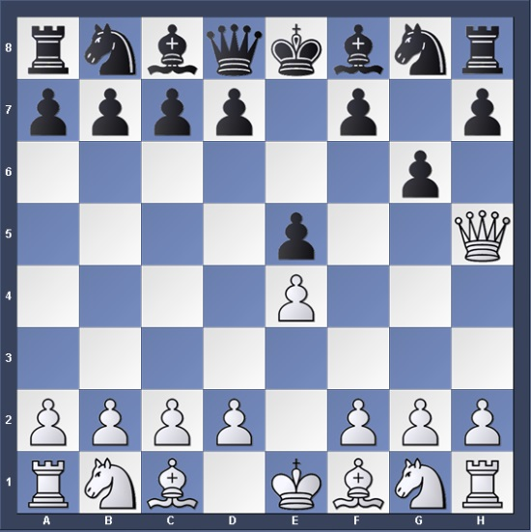

1. **White has to use his Queen to attack the Black King and Knight.**

**White To Play**

|  |  |  |
| --- | --- | --- |
| **Move No.** | **White** | **Black** |
| **1.** |  |  |
|  |  |  |
|  |  |  |

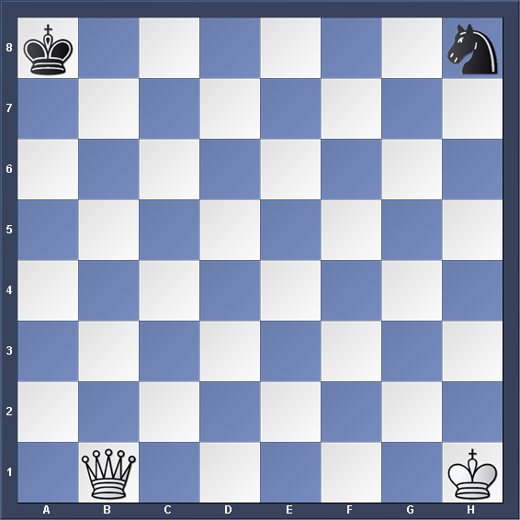

1. **Black to play and find the fork.**

**Black To Play**

|  |  |  |
| --- | --- | --- |
| **Move No.** | **White** | **Black** |
|  |  |  |
|  |  |  |
|  |  |  |

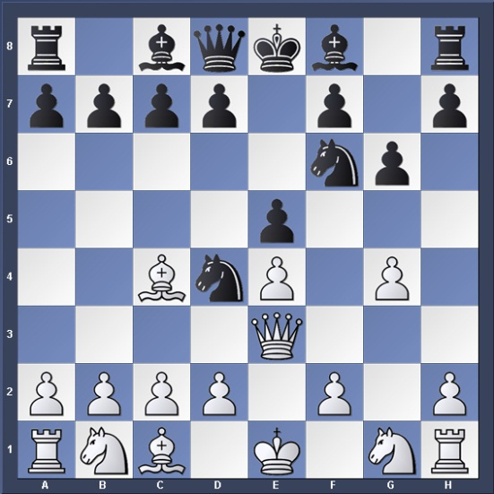

1. **Where should you move the Rook to attack the Black King and Bishop?**

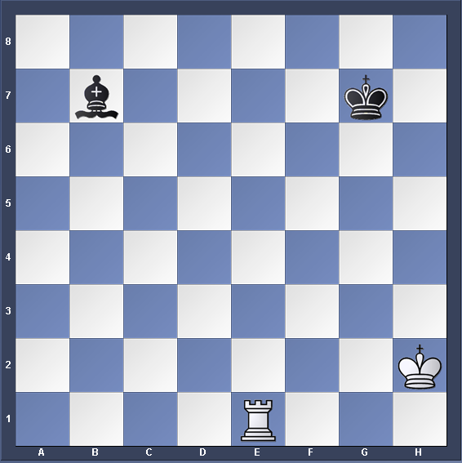

|  |  |  |
| --- | --- | --- |
| **Move No.** | **White** | **Black** |
|  |  |  |
|  |  |  |
|  |  |  |

**White To Play**

1. **White has to play and find the double attack.**

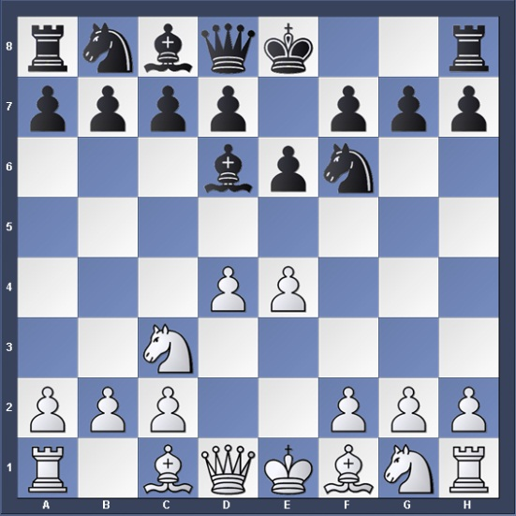

|  |  |  |
| --- | --- | --- |
| **Move No.** | **White** | **Black** |
|  |  |  |
|  |  |  |
|  |  |  |

**White To Play**

1. **White to play and find the fork.**

**White To Play**

|  |  |  |
| --- | --- | --- |
| **Move No.** | **White** | **Black** |
|  |  |  |
|  |  |  |
|  |  |  |

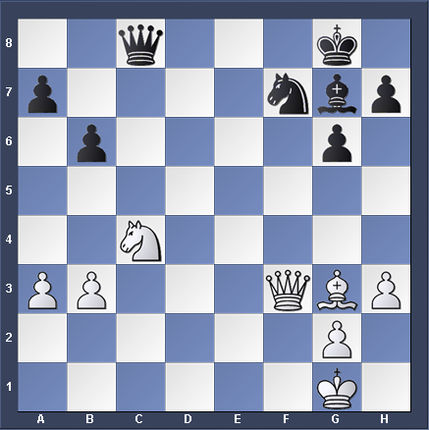

1. **White to play and find the FORK.**

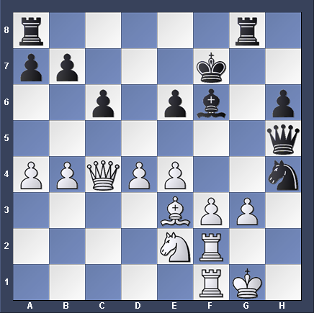

|  |  |  |
| --- | --- | --- |
| **Move No.** | **White** | **Black** |
|  |  |  |
|  |  |  |
|  |  |  |

**White To Play**

1. **Black has to play and find the FORK.**

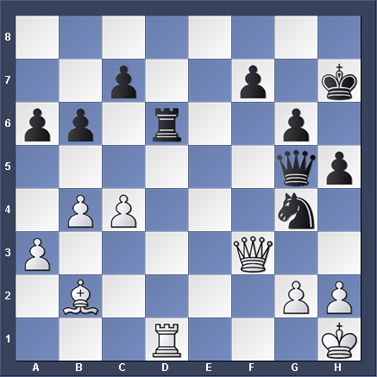

|  |  |  |
| --- | --- | --- |
| **Move No.** | **White** | **Black** |
|  |  |  |
|  |  |  |
|  |  |  |

**Black To Play**

1. **Black to play and find the fork.**

**Black To Play**

|  |  |  |
| --- | --- | --- |
| **Move No.** | **White** | **Black** |
|  |  |  |
|  |  |  |
|  |  |  |

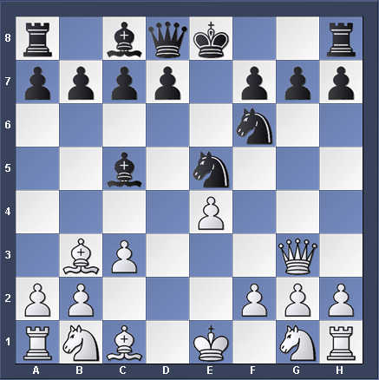

1. **Black to play and find the FORK.**

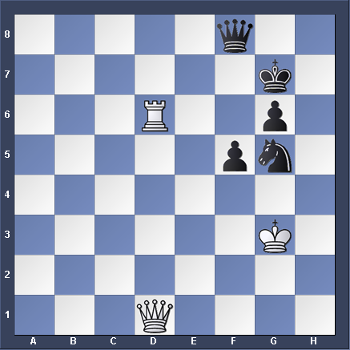

|  |  |  |
| --- | --- | --- |
| **Move No.** | **White** | **Black** |
|  |  |  |
|  |  |  |
|  |  |  |

**Black To Play**

1. **White to play and find the double attack.**

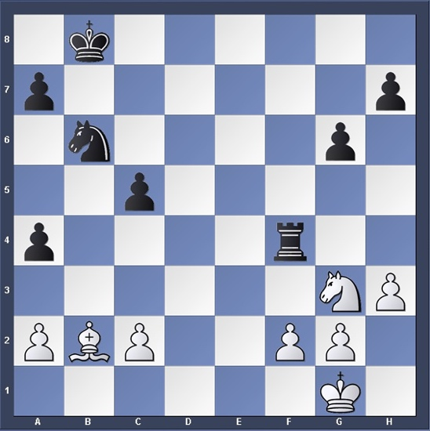

|  |  |  |
| --- | --- | --- |
| **Move No.** | **White** | **Black** |
|  |  |  |
|  |  |  |
|  |  |  |

**White To Play**

1. **White to play and find the double attack.**

**White To Play**

|  |  |  |
| --- | --- | --- |
| **Move No.** | **White** | **Black** |
| 1. |  |  |
| 2. |  |  |
|  |  |  |

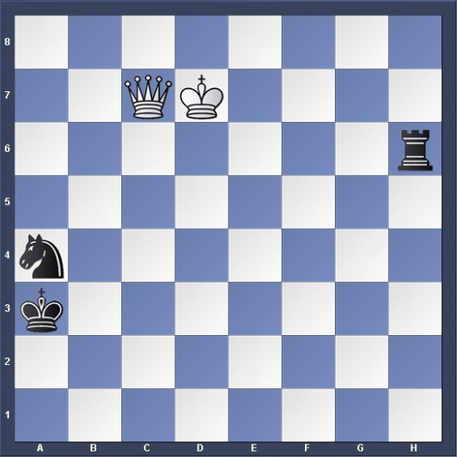

1. **White to play and find the double attack.**

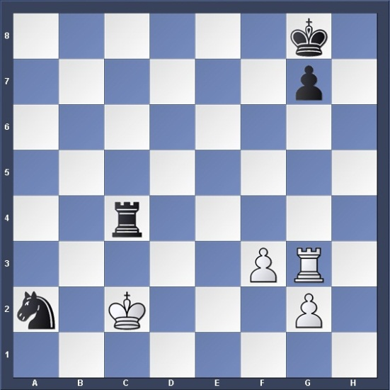

|  |  |  |
| --- | --- | --- |
| **Move No.** | **White** | **Black** |
|  |  |  |
|  |  |  |
|  |  |  |

**White To Play**

1. **White to play and find the double attack.**

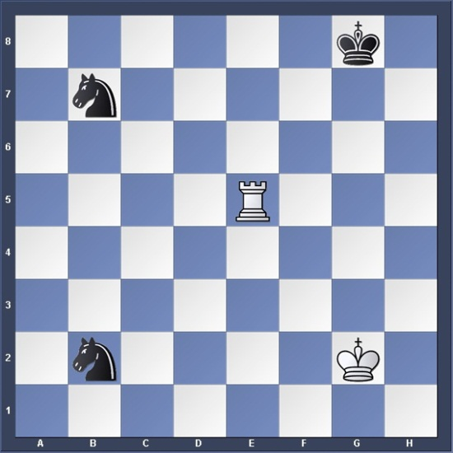

|  |  |  |
| --- | --- | --- |
| **Move No.** | **White** | **Black** |
|  |  |  |
|  |  |  |
|  |  |  |

**White To Play**

1. **White to play and find the fork.**

**White To Play**

|  |  |  |
| --- | --- | --- |
| **Move No.** | **White** | **Black** |
| 1 | Nd6+ | Kd8 |
| 2. | Nxc8 |  |
|  |  |  |

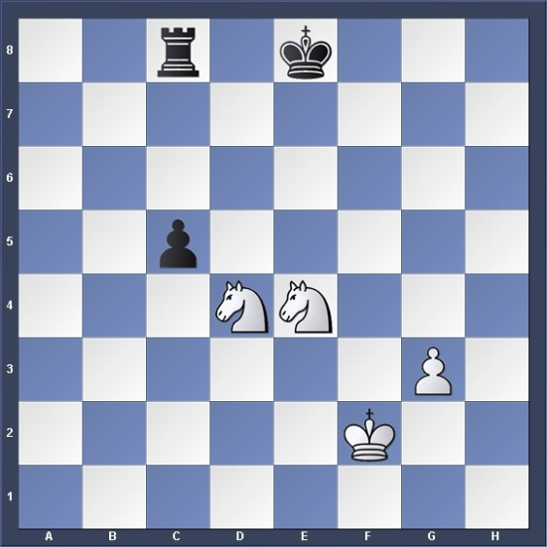

1. **White to play and find the FORK.**

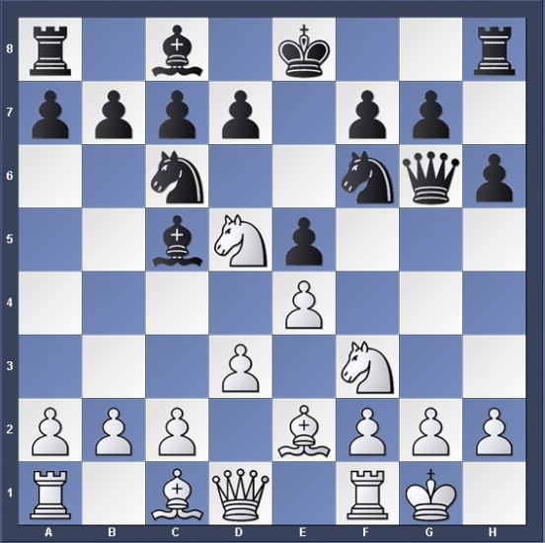

|  |  |  |
| --- | --- | --- |
| **Move No.** | **White** | **Black** |
| 1 | Nxc7+ | Kd8 |
| 2. | Nxa8 |  |
|  |  |  |

**White To Play**

1. **White to play and find the FORK.**

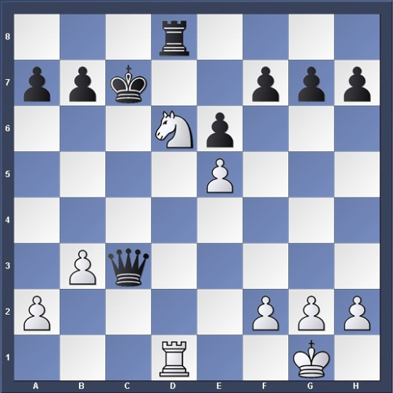

|  |  |  |
| --- | --- | --- |
| **Move No.** | **White** | **Black** |
|  |  |  |
|  |  |  |
|  |  |  |

**White To Play**

1. **White to play and find the double attack.**

**White To Play**

|  |  |  |
| --- | --- | --- |
| **Move No.** | **White** | **Black** |
|  |  |  |
|  |  |  |
|  |  |  |

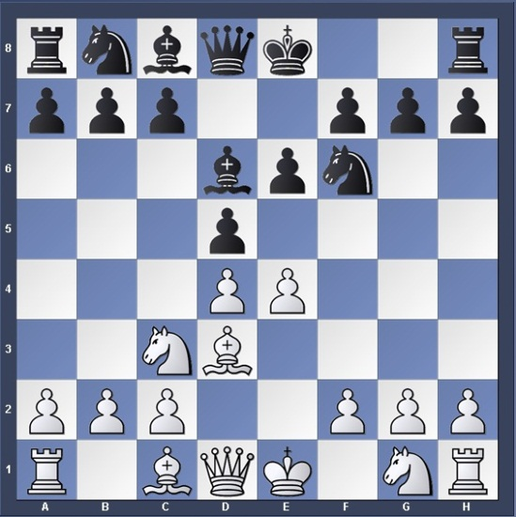

1. **White to play and find the FORK.**

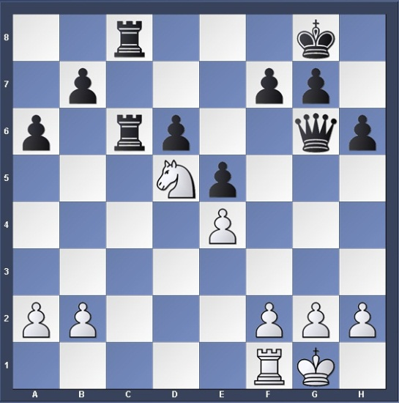

|  |  |  |
| --- | --- | --- |
| **Move No.** | **White** | **Black** |
|  |  |  |
|  |  |  |
|  |  |  |

**White To Play**

1. **White to play and find the FORK.**

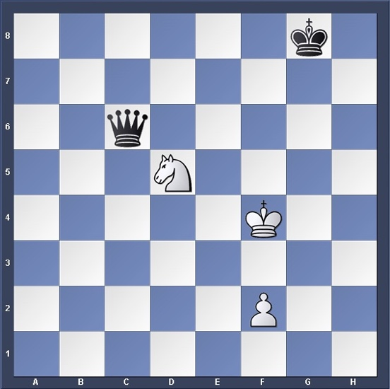

|  |  |  |
| --- | --- | --- |
| **Move No.** | **White** | **Black** |
|  |  |  |
|  |  |  |
|  |  |  |

**White To Play**

1. **White to play and find the double attack.**

**White To Play**

|  |  |  |
| --- | --- | --- |
| **Move No.** | **White** | **Black** |
|  |  |  |
|  |  |  |
|  |  |  |

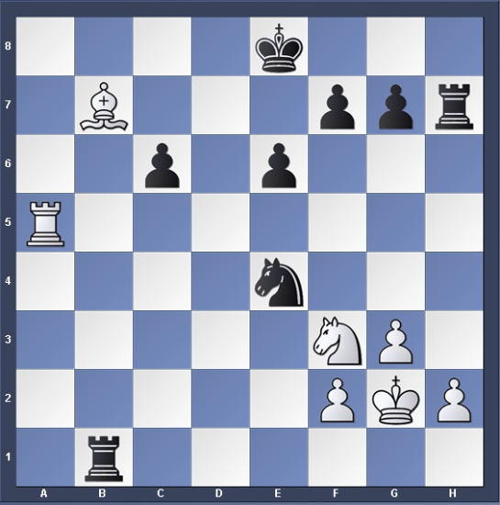

1. **Black to play and find the double attack.**

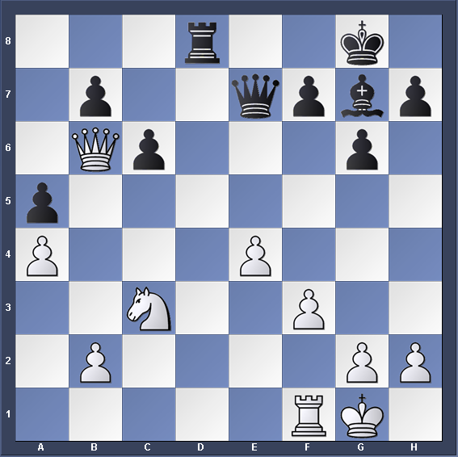

|  |  |  |
| --- | --- | --- |
| **Move No.** | **White** | **Black** |
|  |  |  |
|  |  |  |
|  |  |  |

**Black To Play**

1. **White to play and find the double attack.**

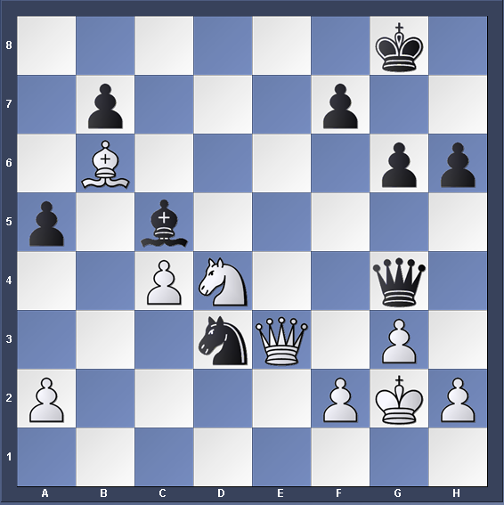

|  |  |  |
| --- | --- | --- |
| **Move No.** | **White** | **Black** |
|  |  |  |
|  |  |  |
|  |  |  |

**White To Play**

1. **White to play and find the fork.**

**White To Play**

|  |  |  |
| --- | --- | --- |
| **Move No.** | **White** | **Black** |
|  |  |  |
|  |  |  |
|  |  |  |

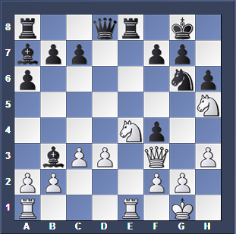

1. **White to play and find the fork.**

**White To Play**

|  |  |  |
| --- | --- | --- |
| **Move No.** | **White** | **Black** |
|  |  |  |
|  |  |  |
|  |  |  |

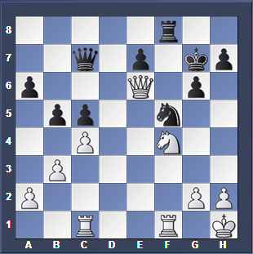

1. **White to play and find the fork.**

**White To Play**

|  |  |  |
| --- | --- | --- |
| **Move No.** | **White** | **Black** |
|  |  |  |
|  |  |  |
|  |  |  |

